Upcoming tasks -volunteers welcome
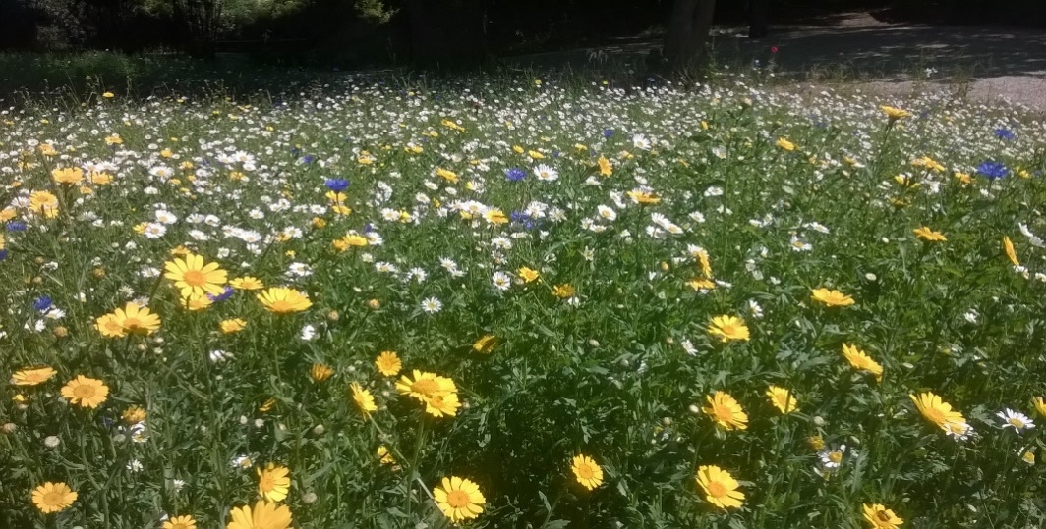
C
ome and join your local conservation group for a spot of green gym as we transform two local verges into wild flower banks. We aim to dig over and clear the sites of grass, nettles and bramble to make way for seed planting. (Bring garden tools if you have them.)
Sunday 14 April 14.00 Meet outside the Good Life Farm Shop in Springvale RoadSO23 7LD
Sunday 5 May Dawn Chorus. 4.40 am Get up with the lark to hear the lark and other bird species as we stroll along footpaths near Itchen Stoke. Bacon butties at the end.
Worthys Conservation Volunteers are a group of local enthusiasts who carry out conservation tasks and wildlife surveys on the third Sunday of every month. We warmly welcome new members. Please check out our website.
www.worthysconservationvolunteers.org.uk
email: enquiries@ worthysconservationvolunteers.org.uk

